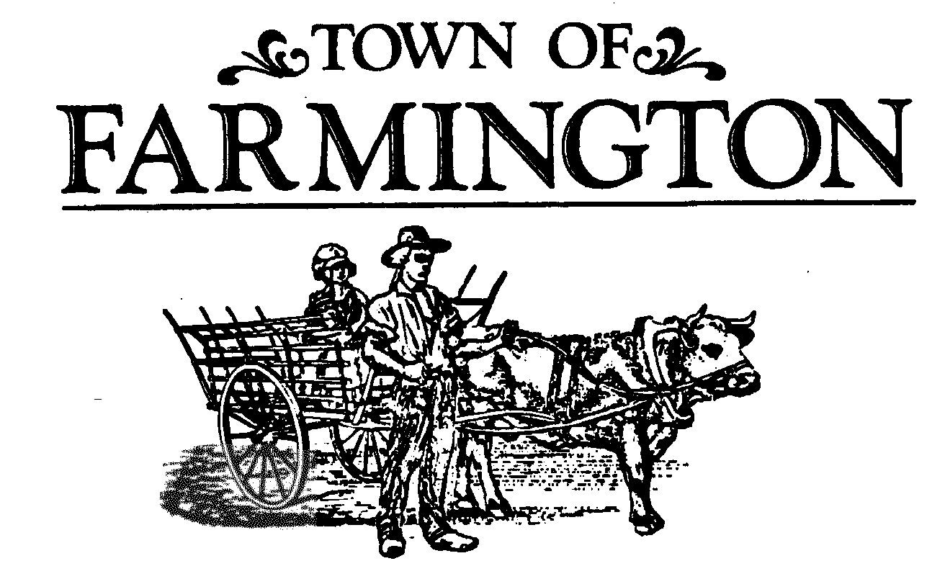

***Planning Board Meeting Agenda***

**February 5, 2025,**

**Meeting 7:00 p.m.**

**THIS MEETING WILL BE HELD IN THE MAIN MEETING ROOM, AT THE TOWN HALL, 1000 COUNTY ROAD 8, FARMINGTON, NEW YORK 14425. THOSE NOT WISHING TO ATTEND MAY PARTICIPATE VIRTUALLY IN THE MEETING BEING CONDUCTED SIMULTANEOUSLY AT THAT TIME ON-LINE, OR OVER THE PHONE. Join the meeting by clicking the following link:**

<https://zoom.us/j/93105325588?pwd=aGlsSkVySklVdTVldnBtWjNJbnlhZz09>

Meeting ID: 931 0532 5588

Passcode: 356169

One tap mobile

+16465588656,,93105325588#,,,,*356169# US (New York)

Dial by your location

+1 646 558 8656 US (New York)

Find your local number: <https://zoom.us/u/adnn0foxAt>

1. **OPEN MEETING** – Chairperson introduces members and Town staff present, identifies the emergency exits and informs that this meeting is to be conducted in accordance with the adopted 2025 Planning Board Rules of Procedure.

2. **APPROVAL OF** – January 15, 2025, MEETING MINUTES.

3. **LEGAL NOTICES PUBLISHED** – Chairperson attests to there being no legal notice published in the Town’s Official Newspaper, the Daily Messenger, for tonight’s meeting agenda.

4. **ORDER OF BUSINESS** -

1. **CONTINUED PUBLIC HEARING (0)**

**There are no continued public hearings on tonight’s agenda.**

1. **NEW PUBLIC HEARING (0):**

**There are no new public hearings on tonight’s agenda.**

-2-

1. **PUBLIC MEETING ACTION ITEMS (0):**

**There are no public meeting action items on tonight’s agenda.**

### 5. OTHER BOARD ACTIONS (1):

1. PB # 0906-22, Hathaway Corners, Phase 2 A, Partial Letter of Credit Release No. 3.
2. PB # 2025-0104, Victor Farmington Volunteer Ambulance Corps, Station 2, Preliminary Site Plan – discussion by Planning Board when a complete application for acceptance.
3. Discussion on NYSDOH, NYSDEC and Natural Fuel Gas replies to the pending SEQR Findings and Determination - Alexander-Shear Preliminary Subdivision Plat Application.
4. Discussion on proposed amendments to Chapter 144, Land Subdivision, Farmington Town Code.
5. Discussion on unnumbered draft local law of 2025 – Short-term Rentals, Chapter 115.
6. Discussion on unnumbered draft local law of 2025- Commuter Lot Parking Regulations, Chapter 153.

6. **OPEN DISCUSSIONS:**

**Reports:** Director of Development

Code Enforcement Officer

Code Enforcement/Zoning Officer

Town Highway/Parks Superintendent

Town Engineer

Environmental Conservation Board

Fire Department

Planning Board Members

Planning Board Chairperson

7. **PUBLIC COMMENTS:**

8. **ADJOURNMENT OF MEETING**

Next Meeting Date: Wednesday, February 19, 2025.